CampusX_statistics

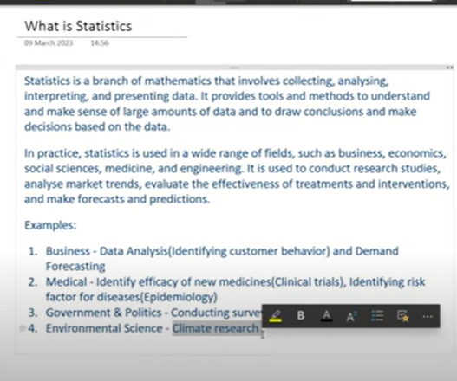

Types of statistics:

Descriptive Statistics

Inferential

Descriptive:

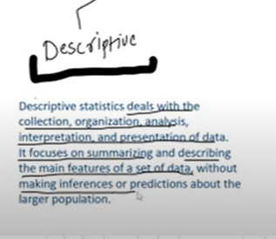

Descriptive : using statistics we generates details / description/ summary

Mean, median,std, 5 mem summary, plot

To study past data

Inferential statistics:

For Prediction we use

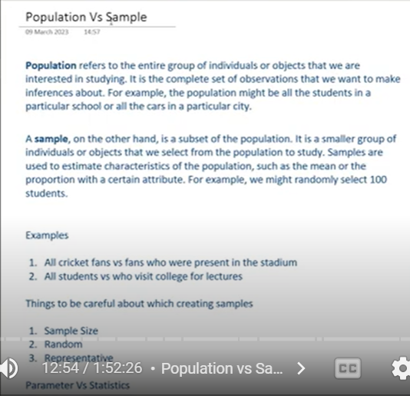

Avg salary of Indians

We need to take salary of all Indian to find avg

Instead of we take sample

Find avg of sample

Based on same we try to infer population

Inferential statistic branch of stats we take sample and based on sample we try try to predict info of population



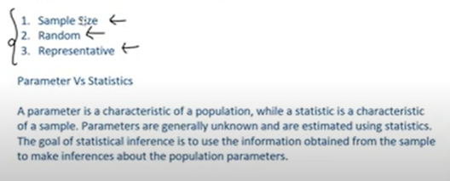

Diff things we do with the help of inferential statistics

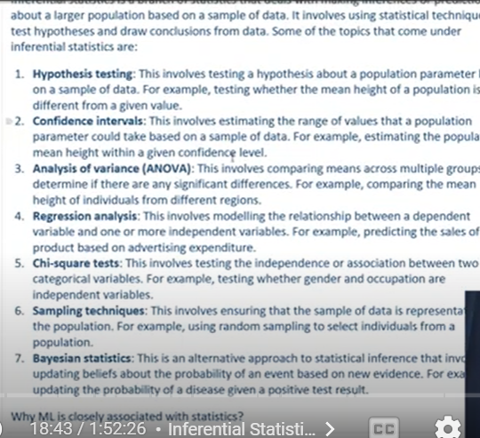

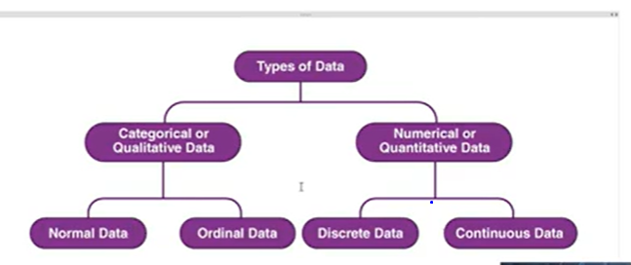

Type of data talks about a particular column:

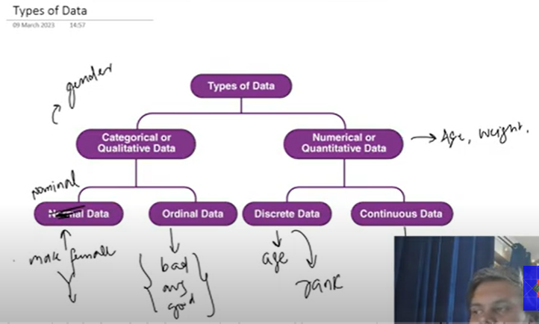

Continuous data : height, weight

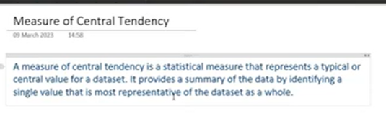

Measure of Central Tendency:

Centrality of data/columns

That represents data set as a whole

Mean

Mode

Median

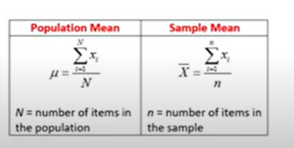

Problem: outlier

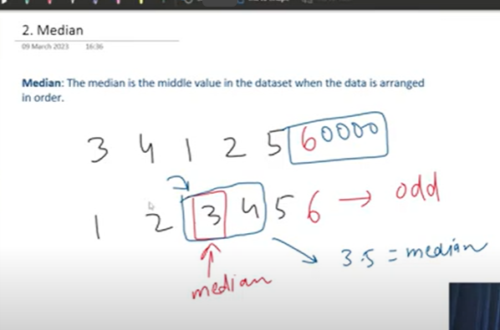

When outliers are there we use median

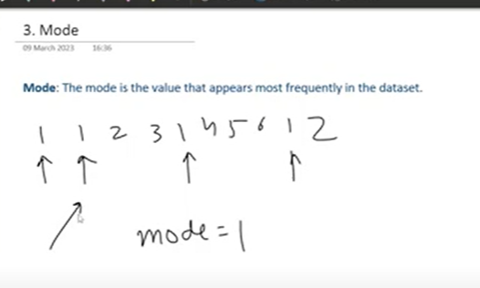

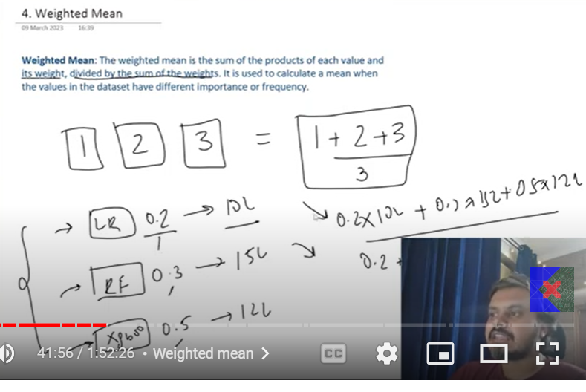

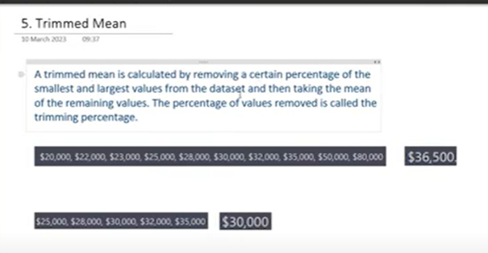

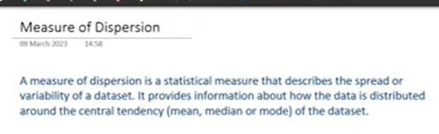

Spread of data

Variability of data

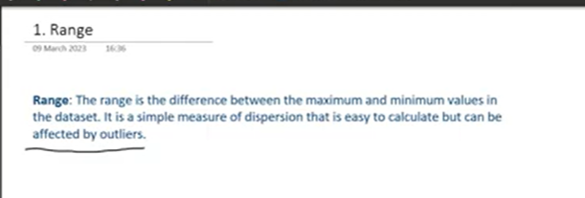

Not reliable – outliers

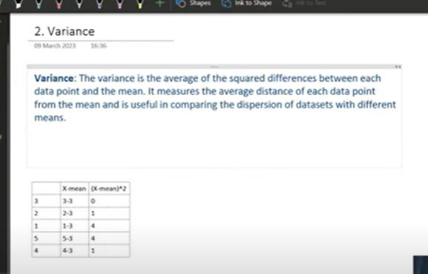

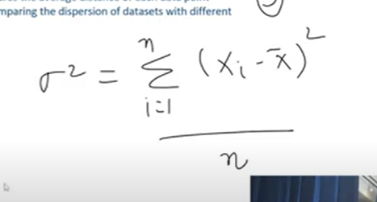

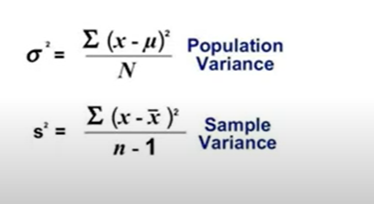

Variance directly proportional to dispersion

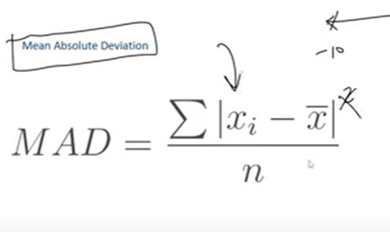

We cant get inference nicely by using MAD though it is less prone to outliers

Thtas y we use variance

Variance effected by outliers

**Standard Deviation**:

Square root of variance

Same unit as data

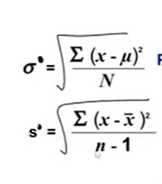

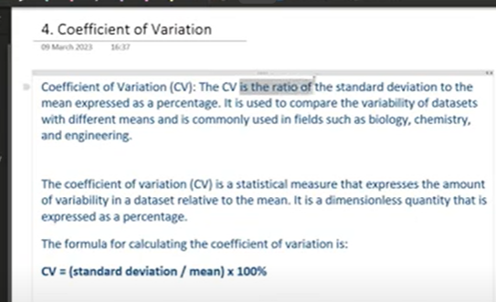

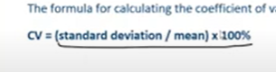

2 columns

Salary and exp

We cant compare mean of salary with exp

Even sd cant compare

To compare the variability we use

Normalized score we get

**Graphs of Univariate Analysis:**



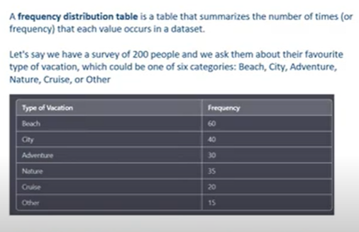

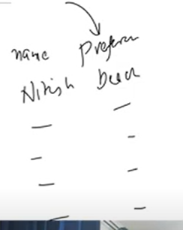

**Pandas value_counts()**

**Bar charts**

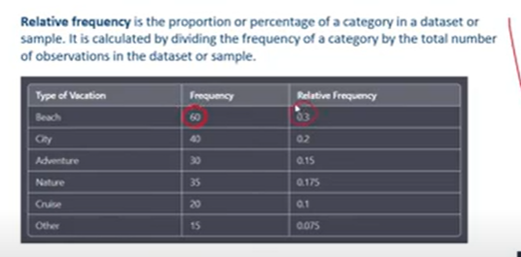

**Percentage of category in dataset**

**Pie chart**

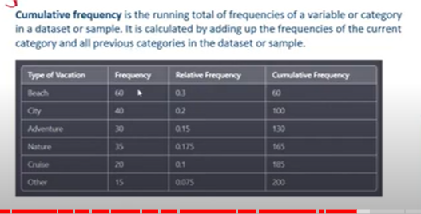

**Categorial data: freq table+relative freq+cumulative freq**

**Bar and pie chart**

**Bar: freq dist of each category**

**Pie: relative freq**

**Cumulative: line**

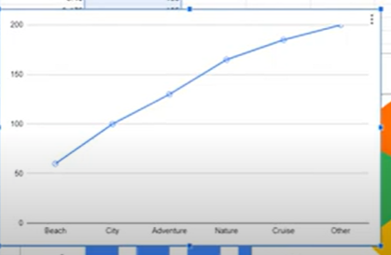

**Numerical**

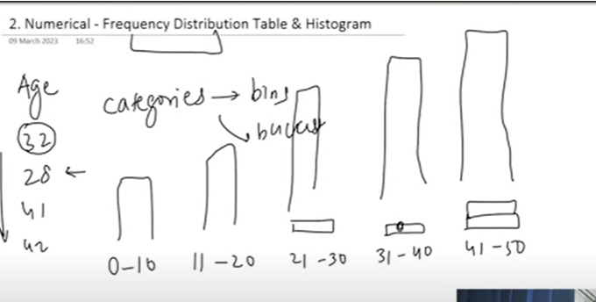

**Histogram**

**Diff shapes of histograms**

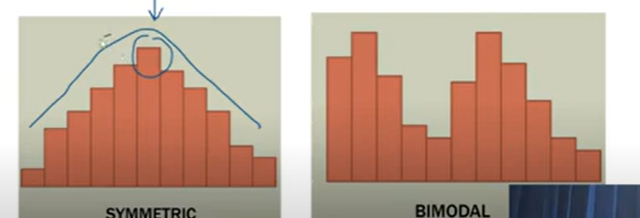

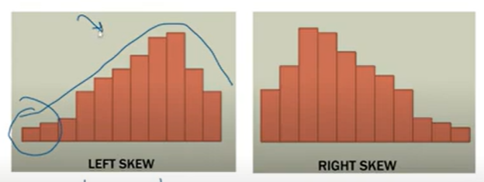

**Left example: marks of people**

**Right skew: salary**

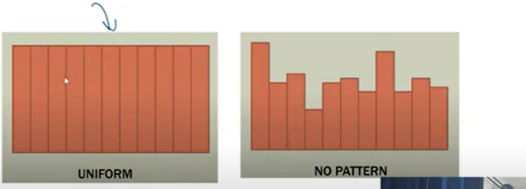

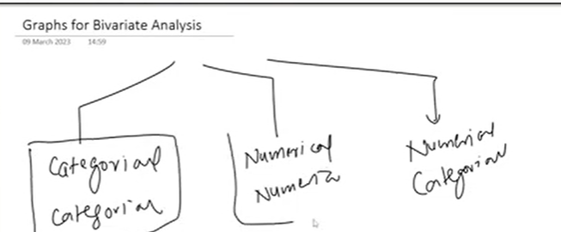

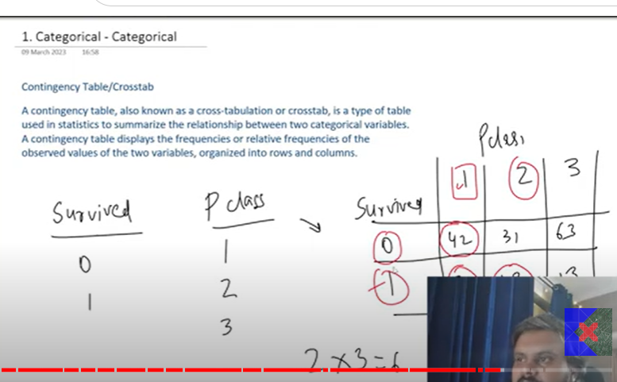

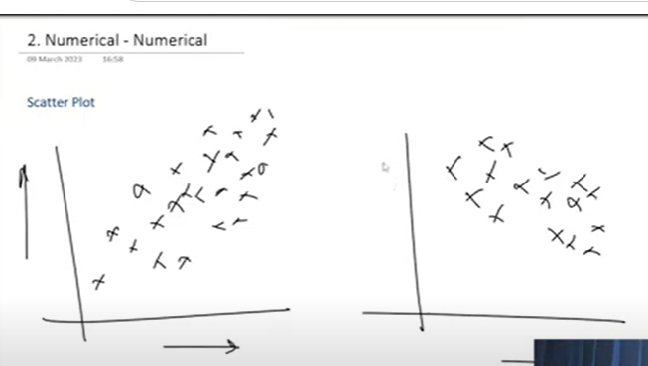

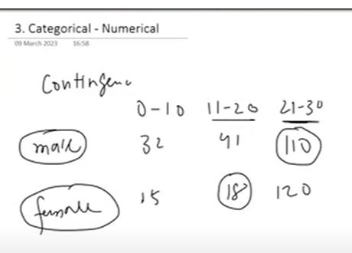

Measure of dispersion: under this we will study 5 number summery

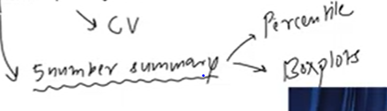

Binary analysis(scatter plot== covariance, correlation coefficient)

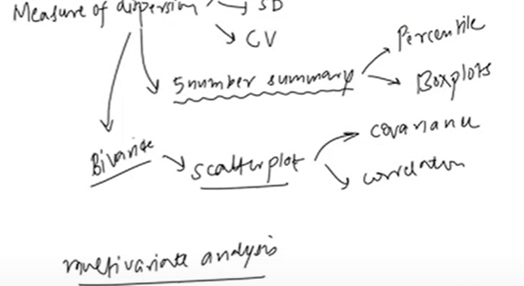

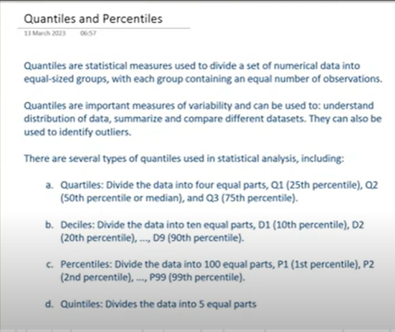

Quantile: used to divide data(numerical data like age ) equal sized groups, each group contains equal number of observations

Each bucket should have equal num of observation

We can even find outliers

Diff types: quartile: divide data into 4 buckets

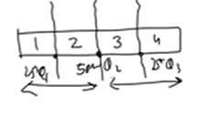

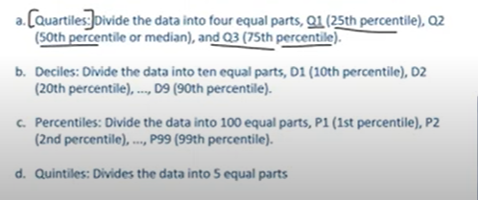

Decile: 10 parts

Percentile : 100 equal parts

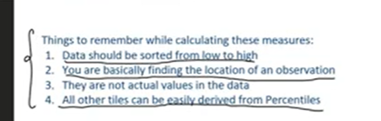

Percentile: 90 per means 90 percentage are under you

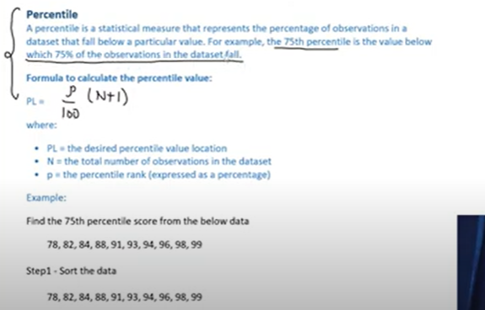

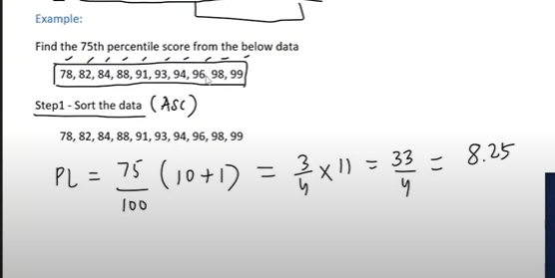

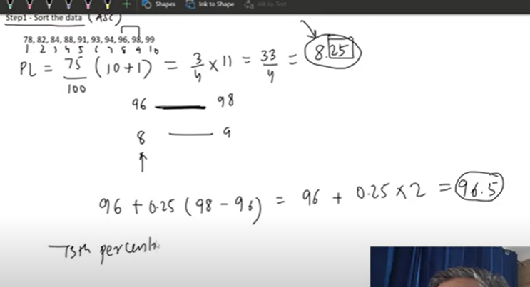

If u get marks 96.5 marks will be in 75th percentile

They are not in dataset

Now based on percentile we calculated marks

;;

Now based on marks we should calculate what percentile would be mde

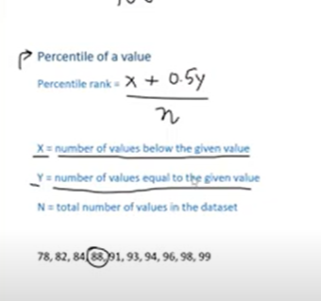

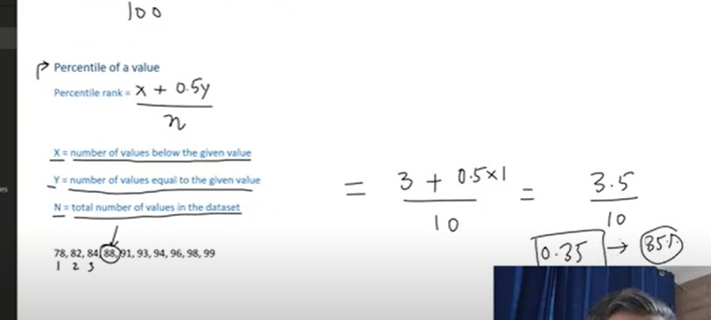

**5 member summary:**

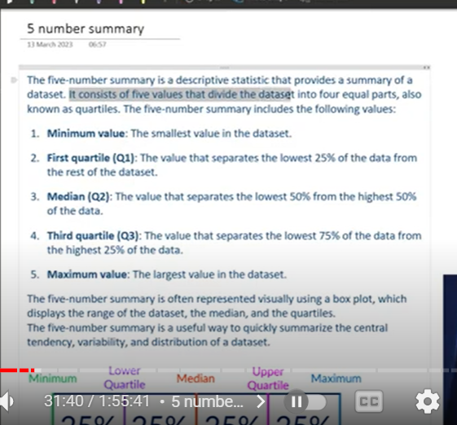

**Divide dataset into 4 qual parts**

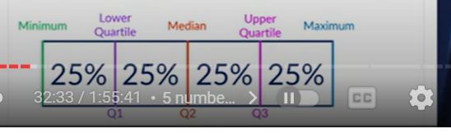

**Pandas describe**

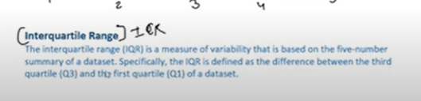

**Q3-Q1**

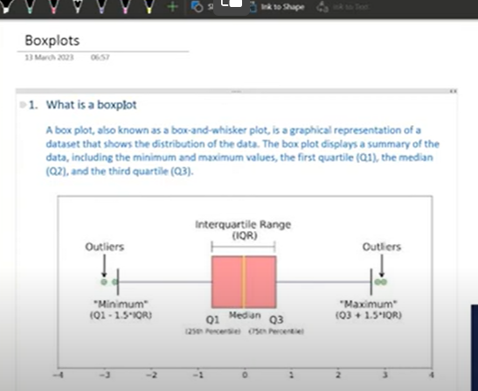

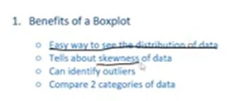

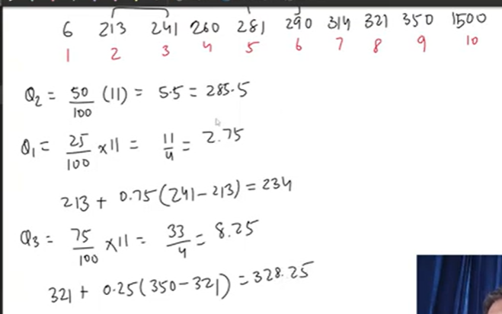

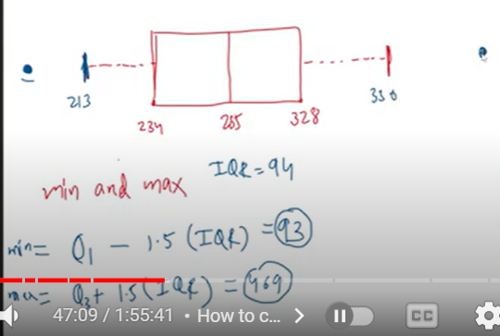

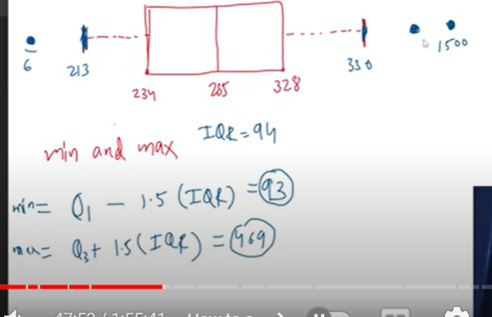

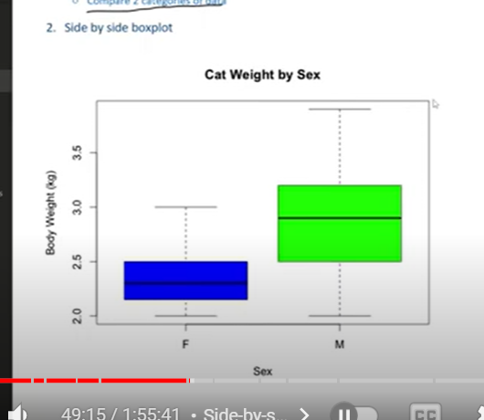

**Side by side boxplot**

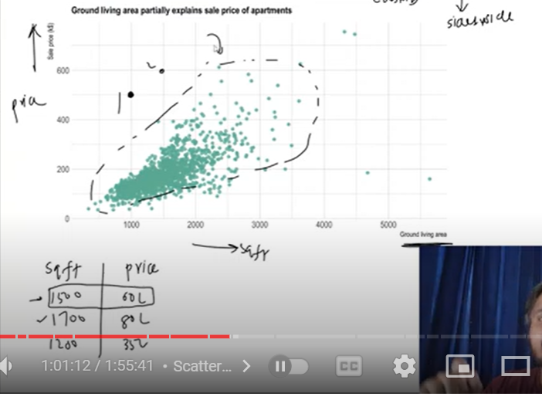

**Covariance:**

**Mean only tells about center but not the spread**

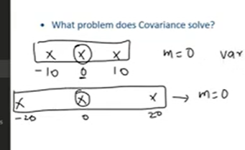

**Here mean is same but spread is diff**

**But variance here is same**

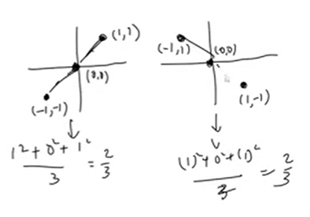

**So variance will not work**

**To solve this covariance**

**This describe degree in which both variables are linearly related**

**How much two variables change together**

**One variable increase – does other variable increase or decrease**

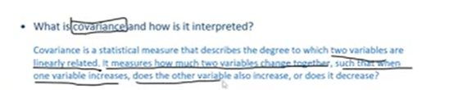

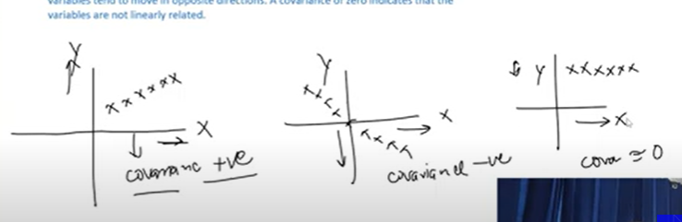

**Positively related or negatively or no relation**

**It tells type of linear relation**

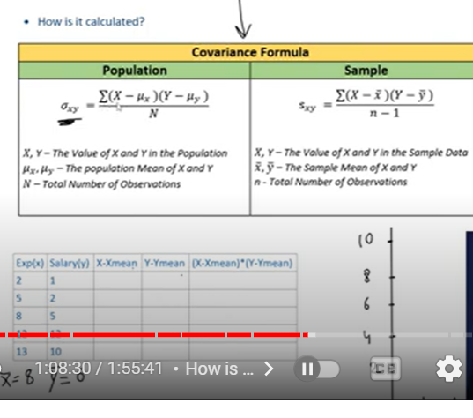

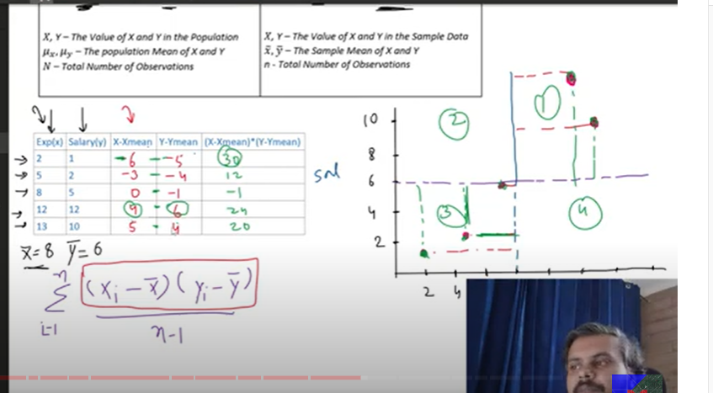

**Points in 1 and 2 places product will be always positive**

**2 and 4 produ will be -ve**

**Ans came +positive so positively correlated**

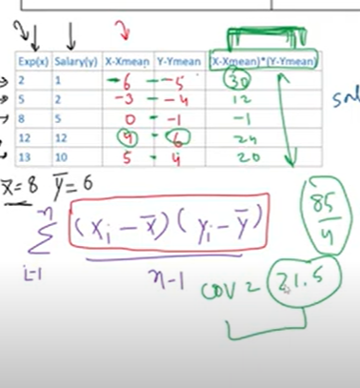

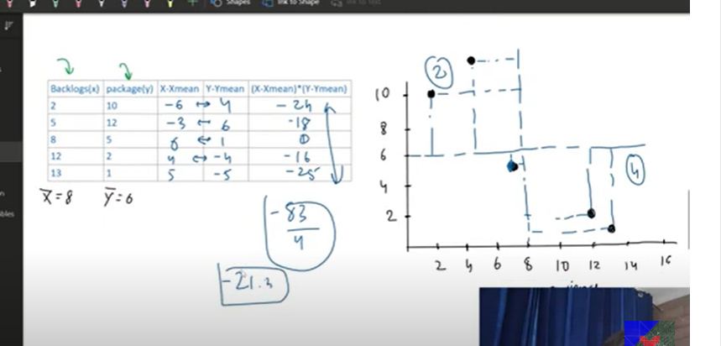**-ve relations**

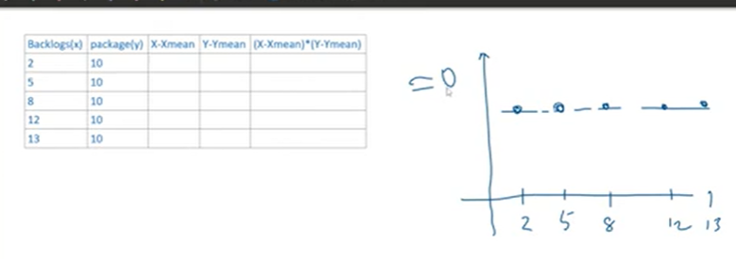

**No linear relationship**

**Disadvantages of covariance:**

**Not much use**

**It doesn’t tell strength/ magnitude of relation**

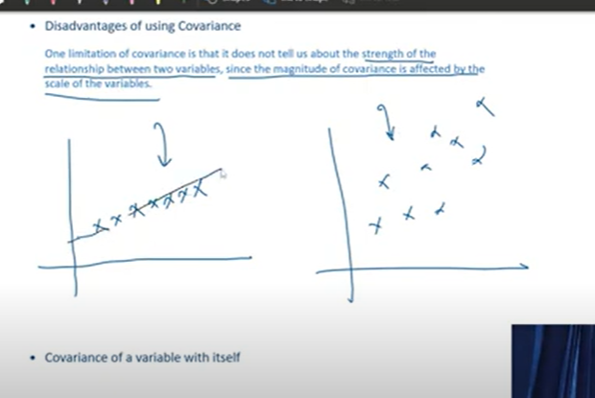

**It only tell direction not magnitude**

**Since the magnitude of covariance is effected by scale of variables**

**Its not reliable**

**If u multiply both x and y by 2 – covariance changes – so not reliable**

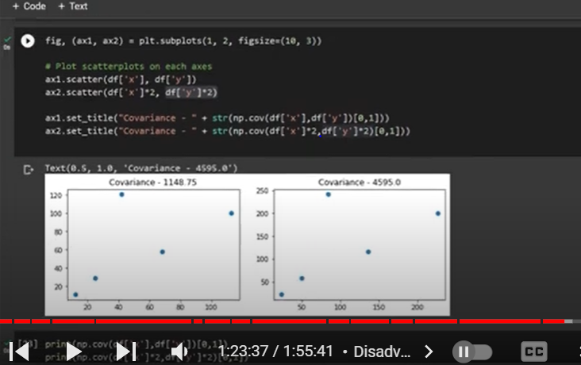

**Though both looks same scale is diff**

**120,250**

**100,200max values**

**Covariance 4 times larger**

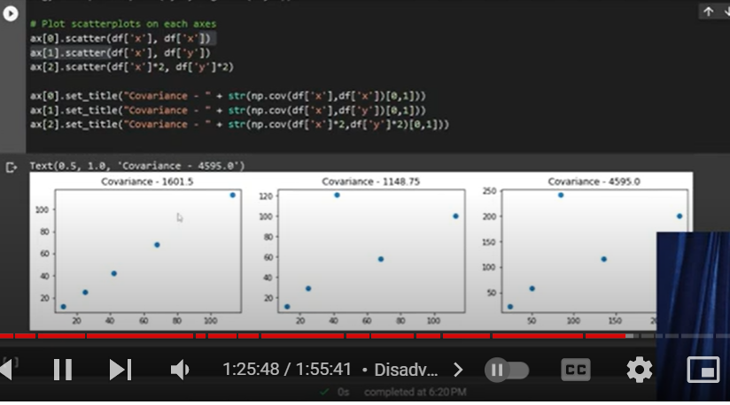

**If u see above 1st graph has high covariance**

**But last one shows high covariance than first**

**So its not reliable**

**It depends on scale**

**It doent tell magnitude or strength**

**To solve this correlation coefficient**

**Its just tell direction of relation/nature**

**And also it used to calculate corr coef**

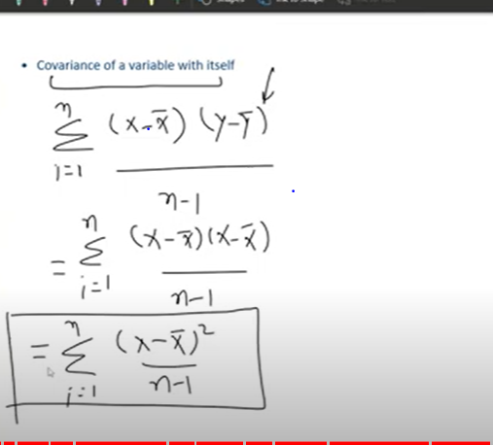

**covariance of variable itself is called variance**

**CORRELATION Coefficient:**

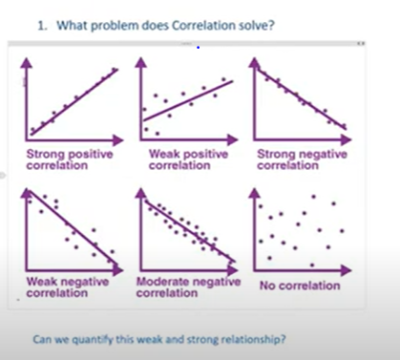

**Linear relation quantifies**

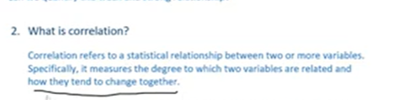

**Both magnitude and direction**

**-1 to 1**

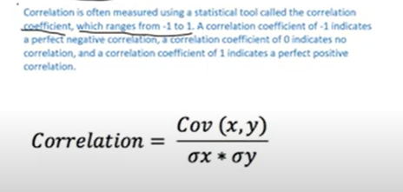

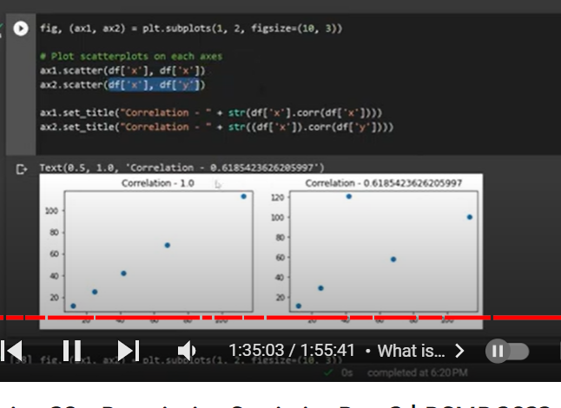

**X,x corr is 1- strong**

**X,y ;0.6 less**

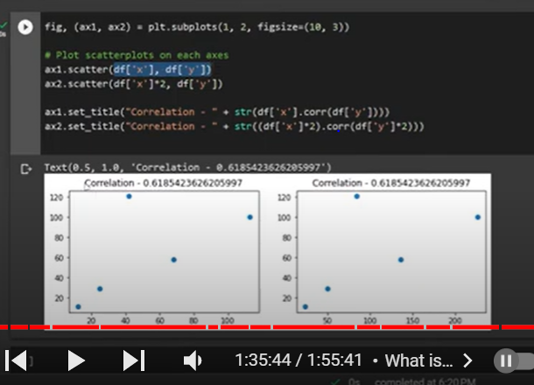

**Ben x,y at diff scale**

**Corr doent depend on scale of data**

**So made it as reliable**

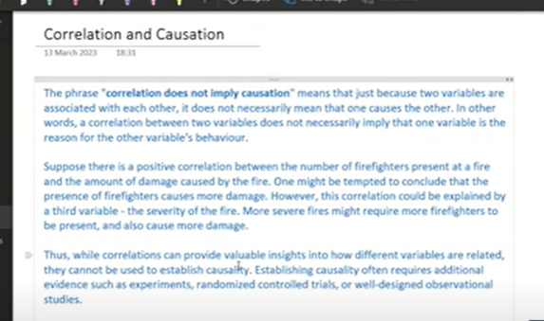

**Correlation doent imply causation**

**One doesn’t need to create other**

**Doent mean that one variable is reason for the behavior of other variable**

**3d scatter plot : 3 numerical**

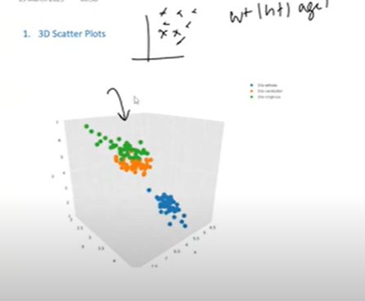

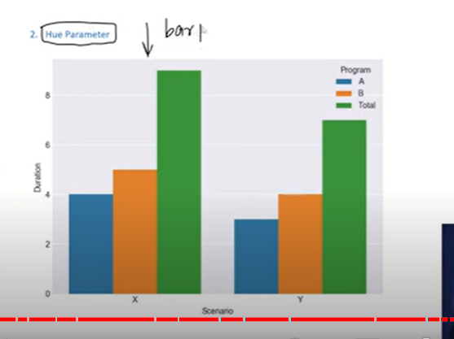

**2 cate , one numeric**

**Male and female avg age (pclass)**

**Facet grids: side by side graphs**

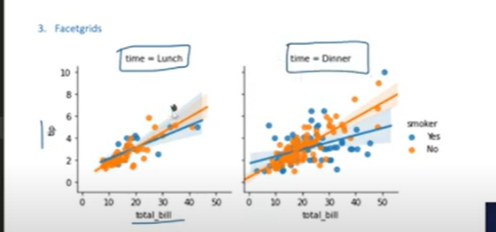

**2 scatter plot**

**4 columns studying at same time**

**Joint plots**

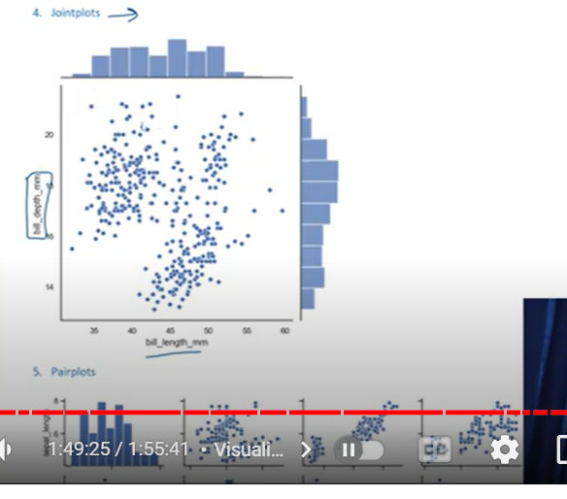

**Scatter plot and histograms**

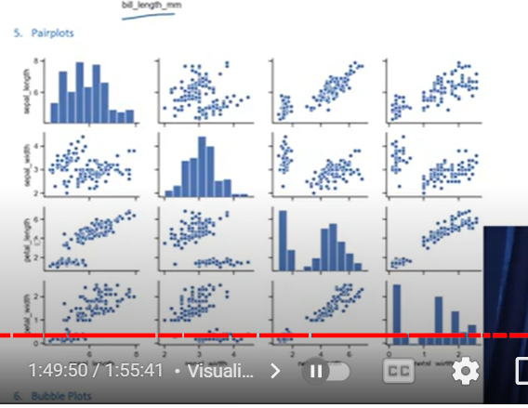

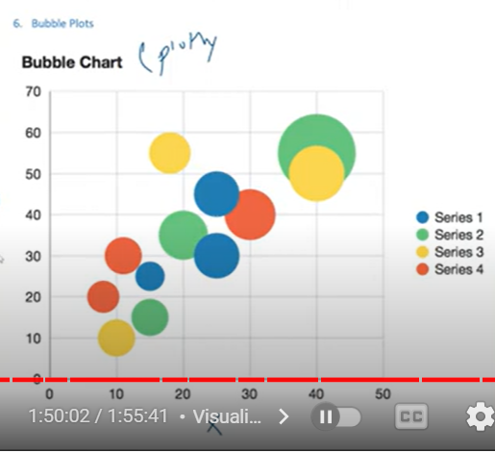

**3 numeric**

**X,y,size of bubble**

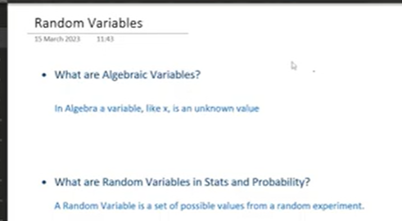

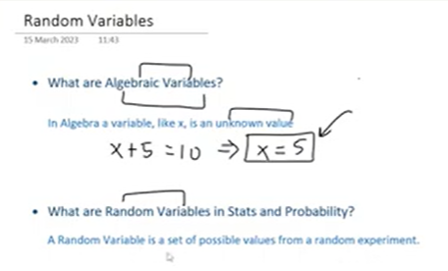

**Random Exp:**

**Any exp that outcome is random, tossing coin – head or tail – random**

**Random variable X**

**Possible outcomes ={head,tail)**

**Dice={1,2,3,4,5,6}**

**Comes randomly**

**Random variable can have multiple variables randomly**

**We denote random variable in capital letter**

**Sample space: all possible outcomes that random variable can have**

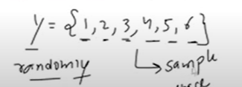

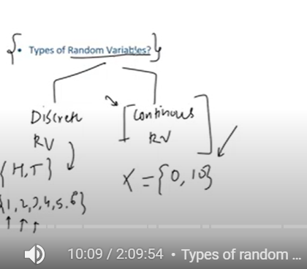

**Probability distribution:**

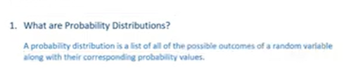

**All possible outcomes of random variable: corresponding probability values**

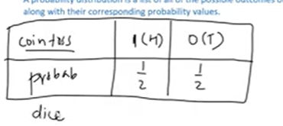

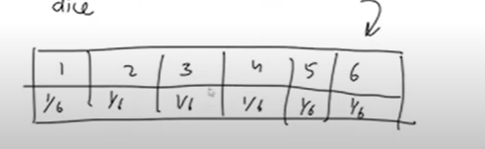

**2 dice together**

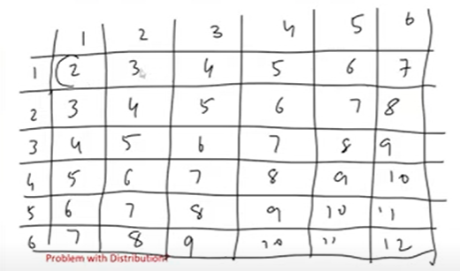

**Total 2 (probability)= 1/36**

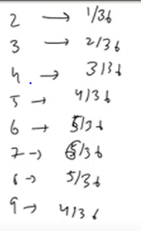

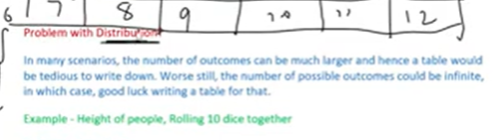

**Problems:**

**many scenarios number of outcomes will be larger –**

**Table is not good idea**

**When random variable not discrete – continuous**

**Solution: how can we show distribution of probability?**

**We need to write mathematical function which shows – outcome and its probability distribution**

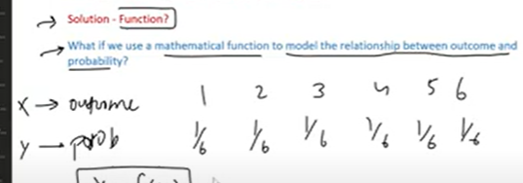

**Function which can say relation between x, y**

**I need to find probability of x**

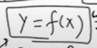

**Solution- Probability Distribution Function**

**It is mathematical relationship between all possible outcomes of random variable and their probabilities**

**We can call probability distribution function as probability distribution**

**TYPES OF PDF:**

1. 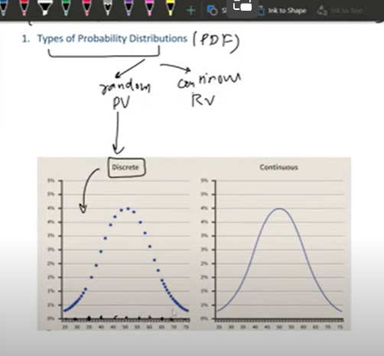

**Discrete random variable distribution(pdf) is not continuous- its discrete graph**

**Continuous random variable: continuous distribution as each value will have probability**

**Famous PD(probability distributions):**

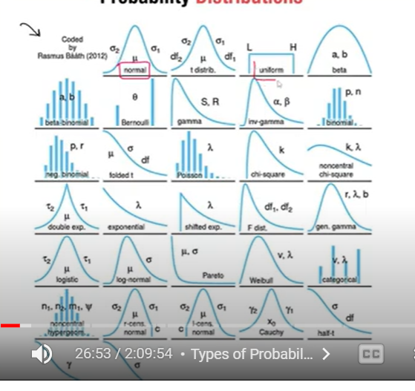

**Normal**

**Uniform**

**Bernoulli**

**Binomial**

**Chi2**

**Exponential**

**Pareto**

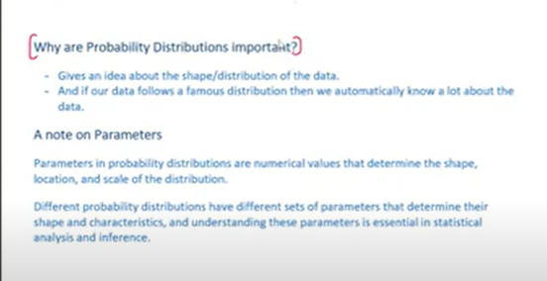

**Graph – gives idea of distribution of data**

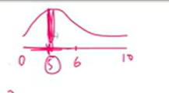

**Above graph says many people got less marks**

**Shape of data**

**Where our data lies**

**When data distribution matches with any famous distribution – can get much info of data**

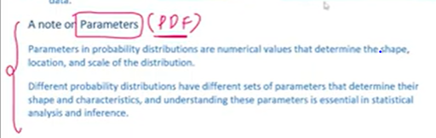

**Each probability distribution have paramers-**

**thy determine shape , location, scale**

**diff PD- have diff parameters**

**Normal distribution: mean and sd**

**PROBABILITY DISTRIBUTION FUNCTION**

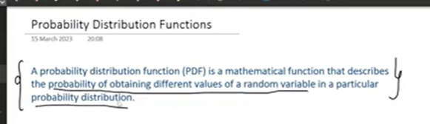

**F(x):y**

**X : all possible out comes**

**Y: their probabilities**

**2 types of probabilities**

**PMF(probability Mass Function)-**

**PDF(Probability Density Function)**

**PMS: discrete random variable probability distribution(dice)**

**PDF: continuous Random variable**

**CDF: can be for both discrete and continuous- called Cumulative Distribution Function**

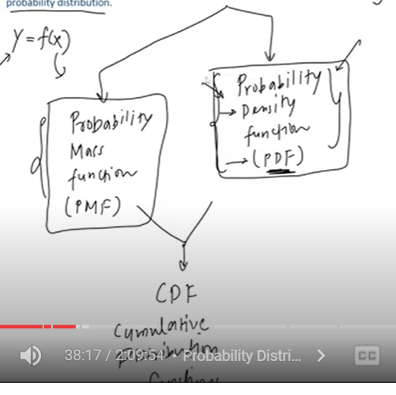

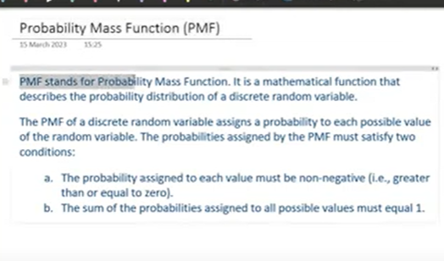

**Pmf: discrete Random Variable**

**Assign probability to each possible outcome**

**Condition: probability of each outcome is between 0 to 1 but not negative**

**Sum of all probabilities =1**

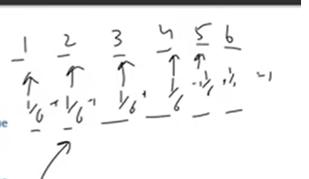

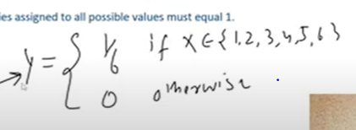

**If x belongs to any outcome between 1 to 6 then 1/6**

**Otherwise 0**

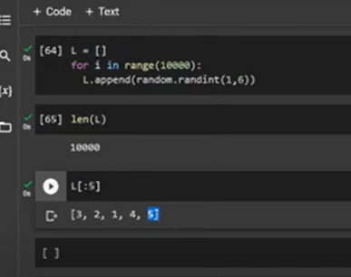

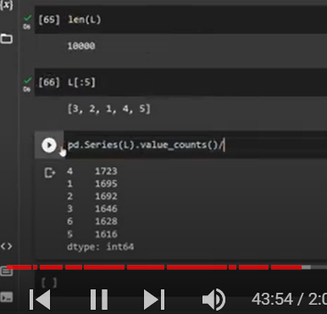

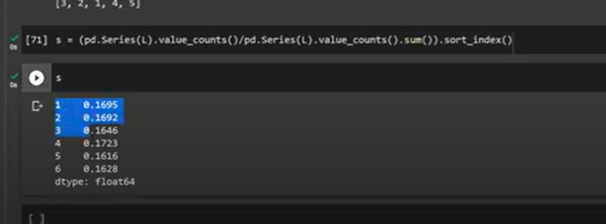

**Probabilities of each outcome**

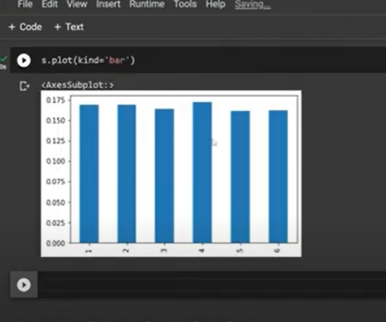

**Almost uniform distribution**

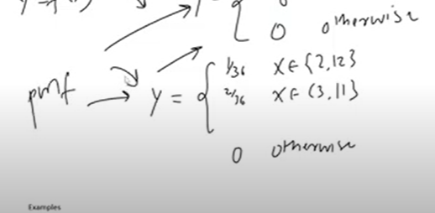

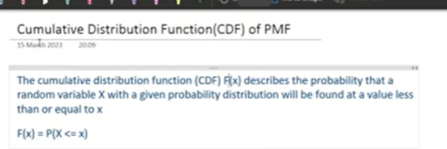

**In pMf= we calculate probability for particular value**

**Like X=5**

**F(x)=prob(x=5)**

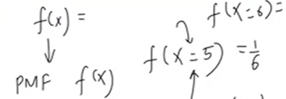

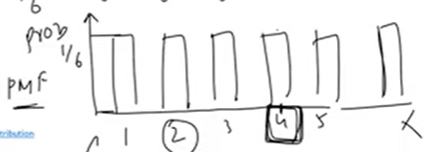

**In CMF:**

**X<=5**

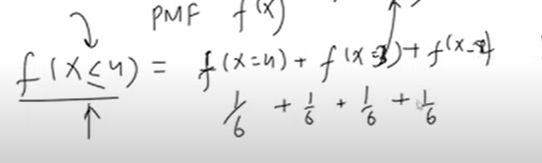

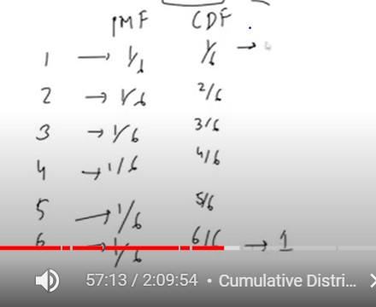

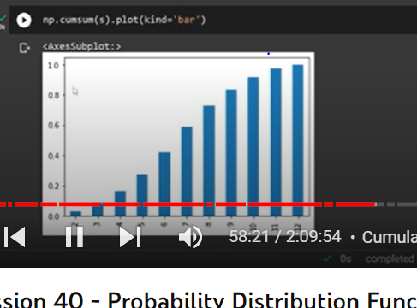

**Probability of all the points upto X**

**PROBABILITY DENSITY FUNCTION**

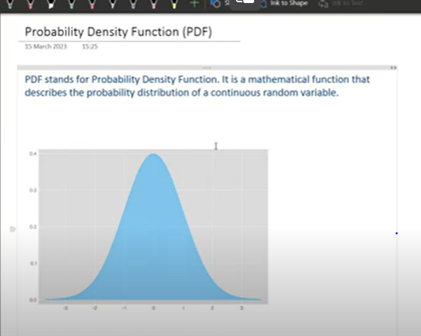

**Probability distribution of continuous random variable**

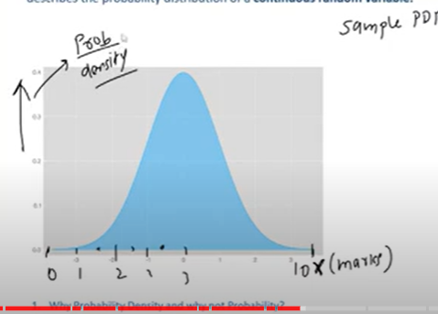

**Here why do we call density function**

**Since other distribution we mention probability on Y axis where as in PDF we mention Probability densities**

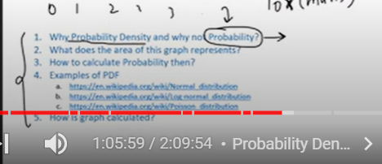

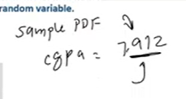

**Probability of above**

**There are infinite numbers on x**

**So probability of a particular datapoint- almost near to zero- so we take prob density**

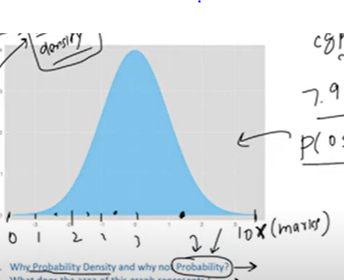

**What is that complete area represent in graph**

**What is the prob a one student of marks between 0 to 10**

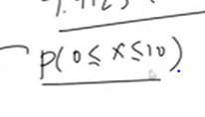

**Pro =1**

**Entire prob of all possible outcomes**

**Probability density gives – what is the prob that the (wat is the prob between 2 numebers)**

**What is the pro that marks between 8 and 10**

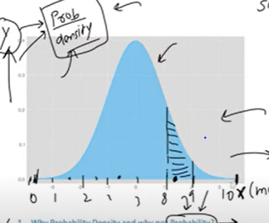

**We only need black – area**

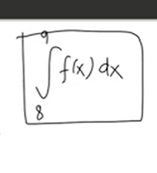

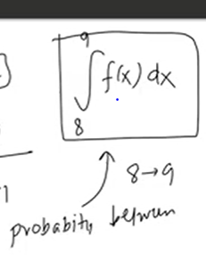

**Roughly we say probability**

**Through integration we find area to find probability**

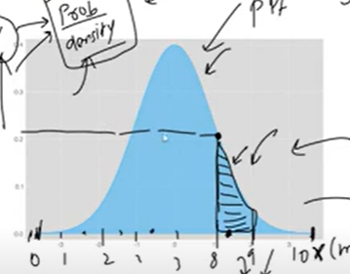

**Y axix: are under the graph is probability**

**Pdf: y has no prob , but prob density**

**Since x has infinite value**

**Here area – tells probability**

**We don’t cal prob for individual points but range**

**How graph Calculated:**

**By using density estimation**

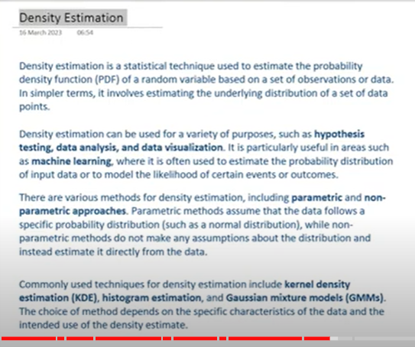

**Parametric: assume data follows specific distribution**

**Non parametric: don’t make any assumption, but estimate directly from data- by calculation**

**Commonly used tech for density estimation:**

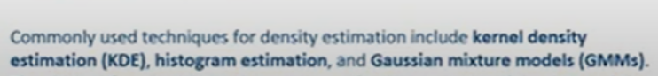

**Parametric Density Estimation:**

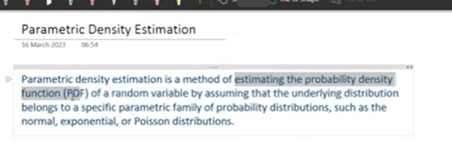**assume**

**Parametric family of distributions- normal, exponential and Poisson**

**We draw some histogram**

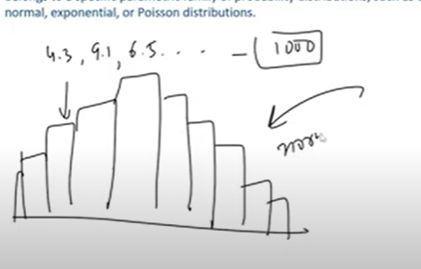

**We assume – data seems to be normal distribution**

**For normal distribution : we need two parameters- mean,sd**

**After assuming we take actual equation – to calculate probability of each values (like 4.3,9.1)**

**Then we plot**



**We generated**

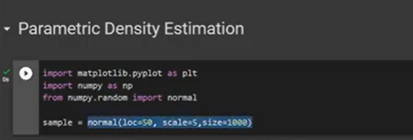

**Data**

**Plotted**

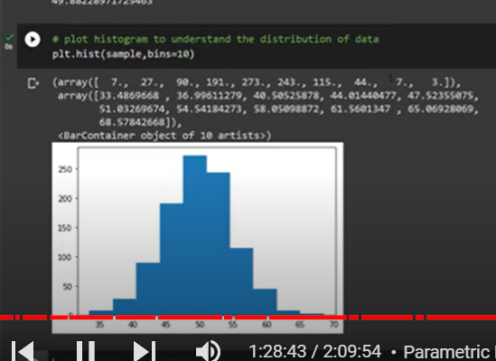

**We cal sample mean and sample sd**

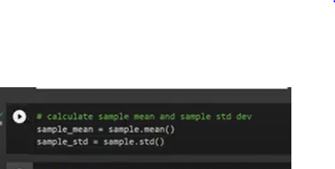

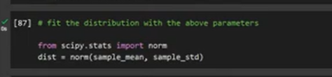

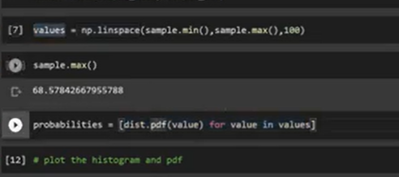

**By using linspace we generated 100 points**

**Each point we cal probability**

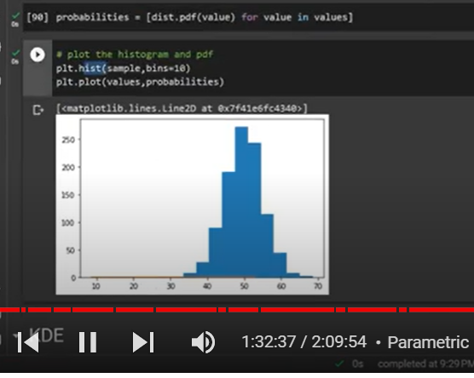

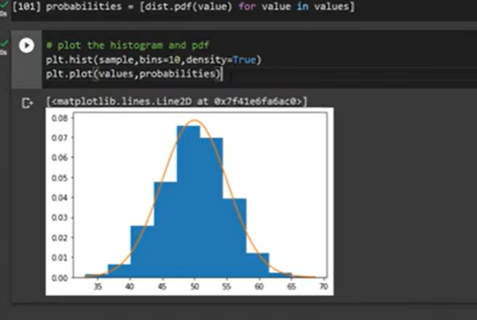

**NON PARAMETRIC DENSITY ESTIMATION: KDE**

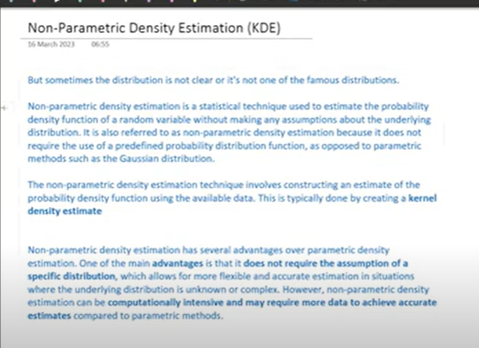

**When distribution is not clear or not one famous distributions**

**Statistical tech used to estimate probability distri without using assumptions**

**Non parametric: becoz it doent req pre defined distribution functions like guassian distrib**

**It constructs – estimate to pro density function by using data points not parameters like(means and sd like parametric)**

**Advan: dones req pre defined distribution**

**Computationally difficult**

**We use kde**

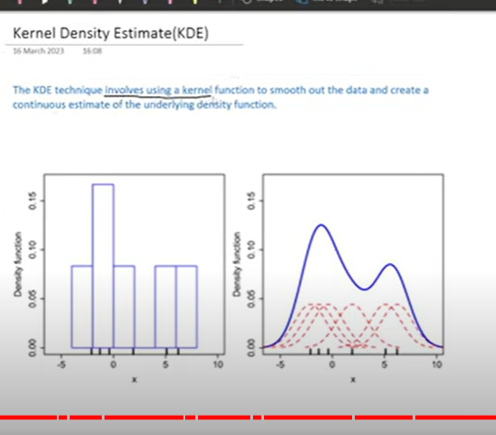

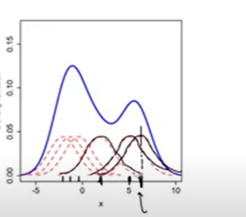

**We take each point and make it as center and make – as mean and create gaussian kernel**

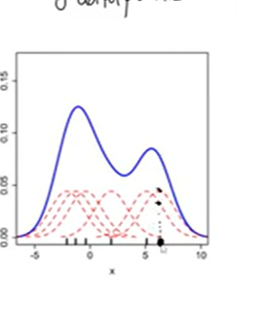

**Take a point draw line perpendicular it touched 2 points- it douched 2 places**

**Cal these distances from x to one poinr**

**X to another point**

**Add them**

**Keep that point to draw kde**

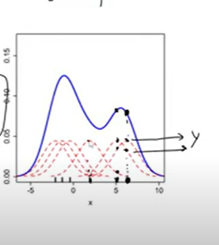

**Each point is mean**

**Bandwidhth – sd(each kernel)**

**High bandwidth – high- smooth curve**

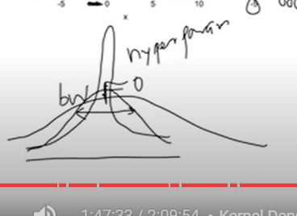

**Low bandwith -peaked**

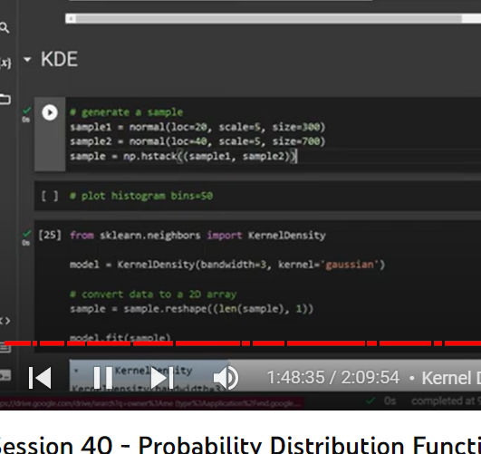

**Histogram**

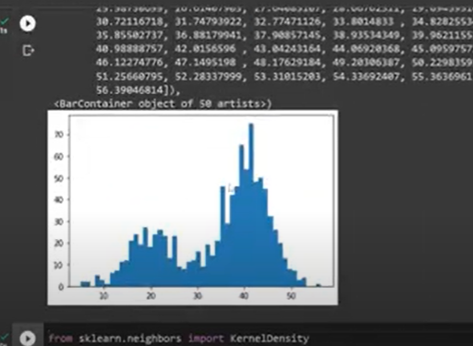

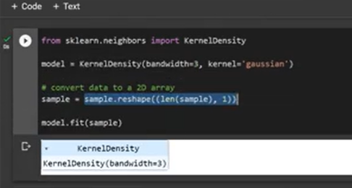

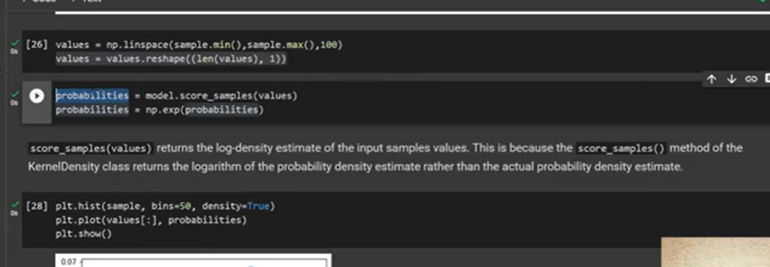

**We fount prob**

**Then we find exp**

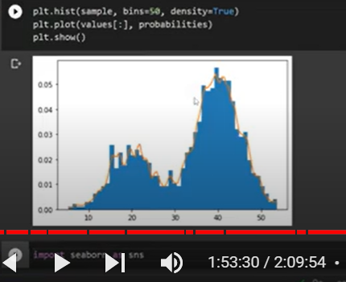

**At bandwih 3**

**Now at 5**

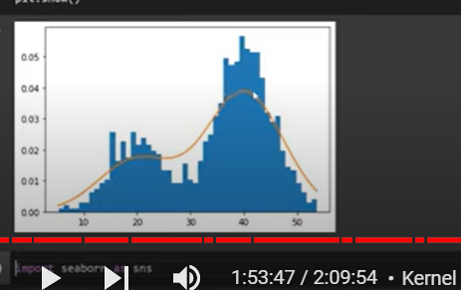

**Curve became smooth**

**CUMULATIVE DENSITY FUNCTION:**

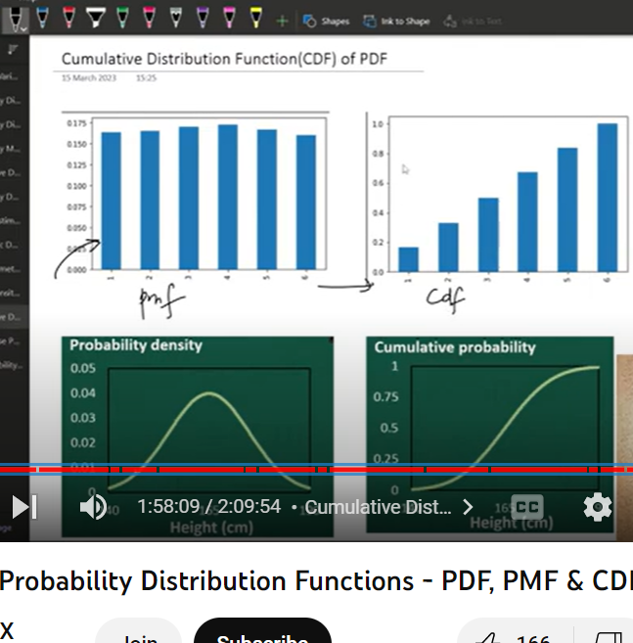

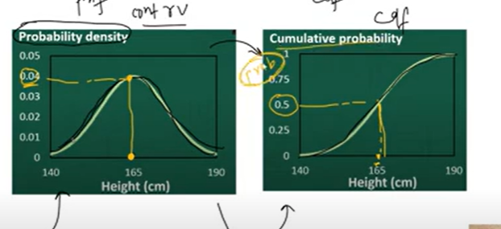

**ON Y AXIS FOR CDF WILL HAVE cumulative probability**

**Prob below 165**

**Prob above 165**

**Cdf can be made from area of PDF- by integration**

**Where as pdf can me made from slop of each point of cdf- differentiation**

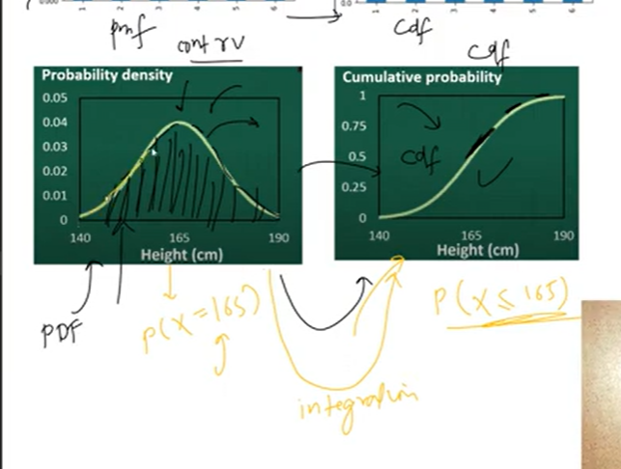

**Normal Distribution**

**Use of pdf in data science:**

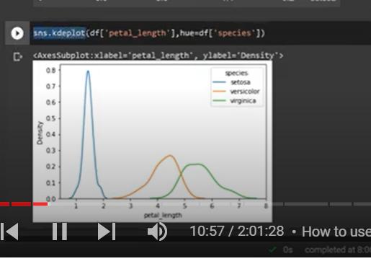

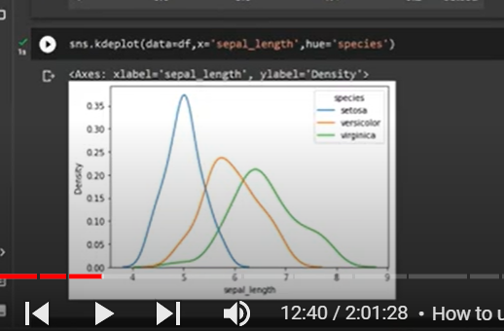

**By this plot we can understand**

**Sepal_leng above 7.5 can be verginica**

**Below 7.5 can be versinica and virinca**

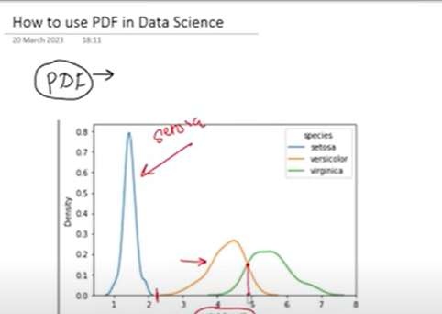

**Line at 5 is separator**

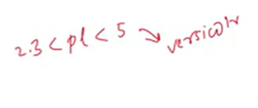

**Since prob density of versicolor is dominating**

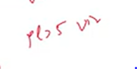

**Virginica**

**So petal length is good indicator to differentiate**

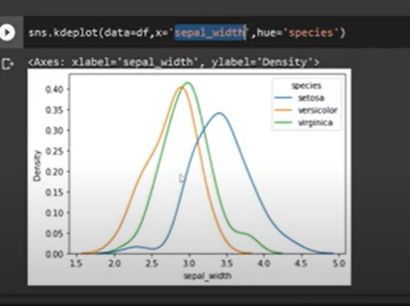

**Diff-**

**As all of them mostly similar**

**So we can keep petal length- to distinct**

**In- titanic**

**Age- survived**

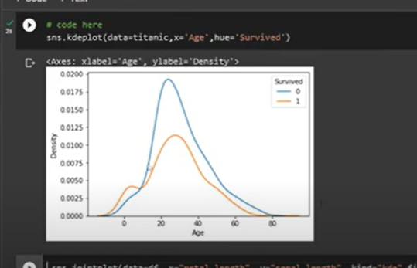

**Age below 8 – high prob of survival**

**After age 8 : high probability of not survived**

**CDF:**

**Cdf example:**

**In sns ecdf plots like cdf**

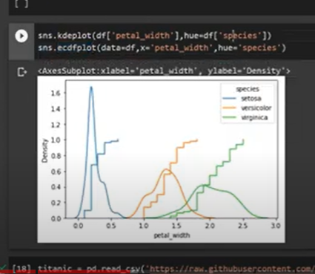

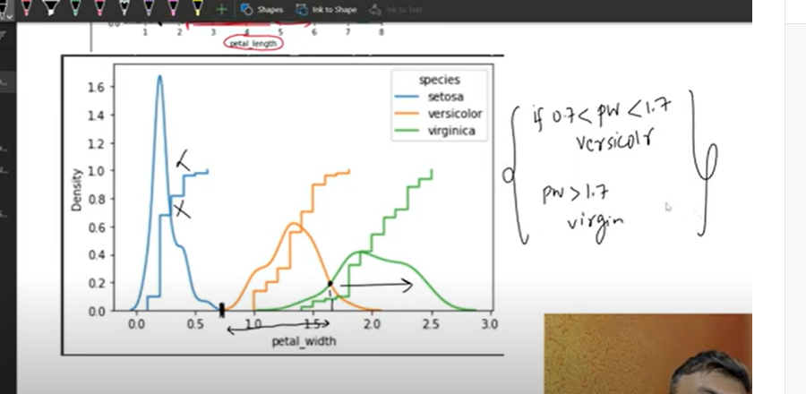

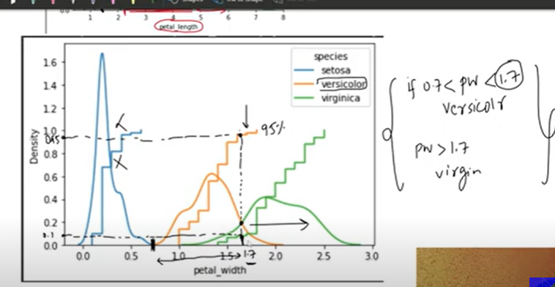

**95 percentage of flowers of versicolor is below 1.7**

**Only 10 perc of Virginia will be less than 1.7**

**95 percentage of time change of a flower become versicolor – 1.7 below- vesicolour**

**We can make these decision**

**--**

**Cdf : we can say how much correct we are**

**95% correct**

**5% wrong**

**2d distribution plot: we take 2 columns**

**3d: 3 columns**

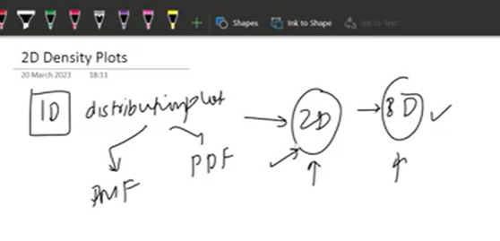

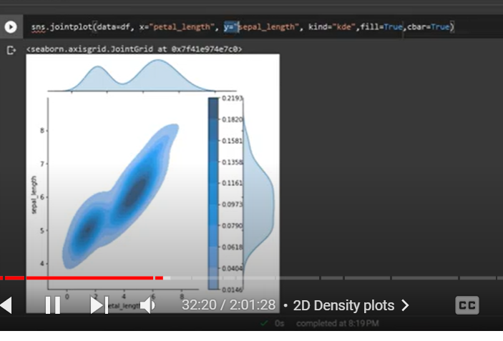

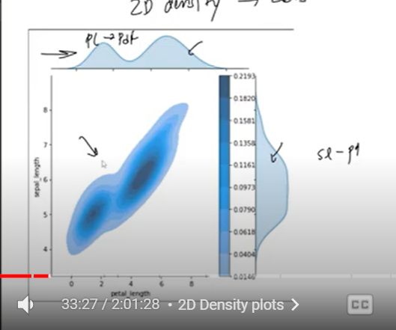

**Normal distribution:**

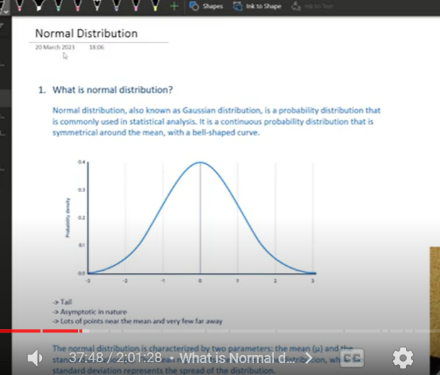

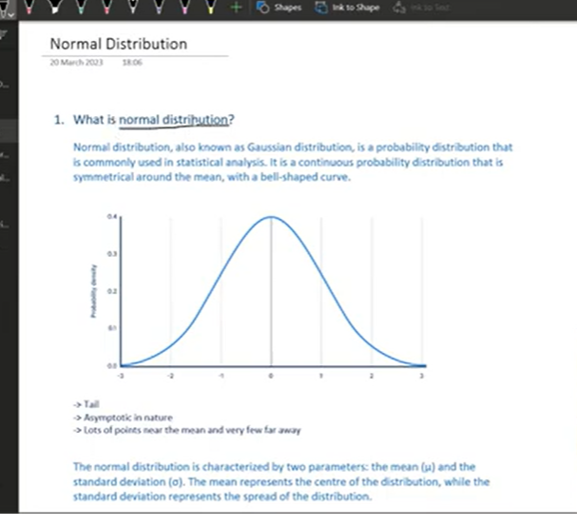

**Also known as gaussian distribution**

**Continuous Probability distribution-pdf**

**Symmetrical around mean with bell shape**

**Tails will not touch x asis – infinite**

**Most points are lied at center**

**Few points at tails**